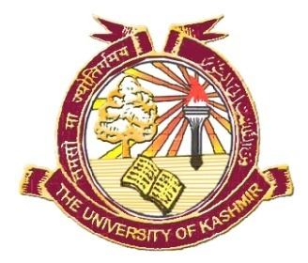
OFFICE OF THE DEAN, SCHOOL OF
APPLIED SCIENCES & TECHNOLOGY
University of Kashmir Srinagar

No: KU2025/DFAS/ Guest Faculty)
Dated: 25-06-2025

WALK-IN-INTERVIEW

The walk-in-interview for appointment of Guest Faculty in Computer Science for Kupwara Satellite Campus of University of Kashmir is scheduled on 1st July 2025 from 11:00 A.M to 01:00 P.M in the office chamber of the undersigned housed in Old Administrative Block, University of Kashmir, Srinagar. Desirous candidates with MCA/M.Tech (CSE/IT) with NET/SET/Ph.D in the relevant subject with 55% marks at P.G. level can appear for the interview. The salary will be consolidated Rs 20,000/- P.M. Applicants are advised to download application form from university website www.kashmiruniversity.ac.in and bring all the testimonials along with them for verification of their credentials.

(Prof. Z.A. Bhat)
DEAN

Copy to:

- Director, Kupwara Satellite Campus, University of Kashmir;
- Head, Department of Computer Science, University of Kashmir.
- Director, IT & SS, with the request to upload the notification on the official website of University of Kashmir;
- Assistant Registrar (information ), PRO Cell, for Publishing the notice in two prominent local dailies English and Urdu;
- File.

